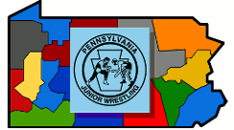

**To Area VIII Chairman: Justin Motter**

**This form is to be completed if you have a 9th Grader that is eligible to compete in the PJW Jr. High Pennsylvania State Championships.**

I certify that Wrestler is a Jr High Eligible Wrestler.

Who attends School District.

**He/She has NOT competed in any PIAA Practice, Scrimmage, or Match with a Varsity Wrestler.**

**Athletic Director/Principal:** Print

Signature

**High School Coach:** Print

Signature ___________________________________________________

**Please bring completed form to the Seeding Meeting on Friday February 14th**